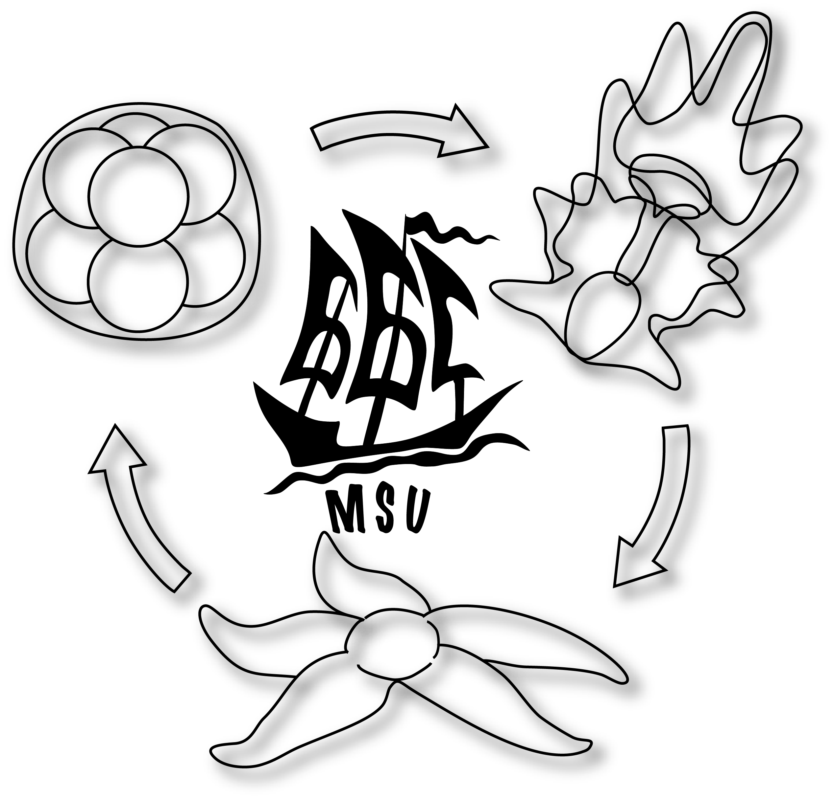
Summer Course in Embryology of Marine Invertebrates
The White Sea Station
12/06 - 03/07, 2016

PROGRAMME
The labs are always open and people can work there as long as they want. Normally we have breakfast from 8:00 to 9:00, lunch from 13:00 to 14:00, tea-time 17:00-17:15, and dinner 20:00–21:00. Daily schedule starts at 9:00, evening lectures are from 21:30 to 23:00. The correct time of field trips will be determined by the tidal schedule.
On-duty students (by pairs) are responsible for the plankton sampling at the pier, measuring of sea water temperature, and cooling the water if needed.
DAY 1 - SUNDAY - 12.06.2016
Arrival and accommodation at the White Sea Biological Station (WSBS); safety instructions; organization of workplaces, excursion around the WSBS.
Lunch (14.00 – 15.00)
Laboratory introduction (15.00-16.30): Nadezhda Rimskaya-Korsakova +Denis Nikishin + Andrey Prudkovsky - the basic principles of working with cultures of embryos and larvae in a laboratory; the water-flow aquaria; review accessible equipment and literature; general principles of zoological drawing»
Field excursion (16:30-17:30): Yulia Kraus and Igor Kosevich - plankton sampling with row boats and sorting of plankton samples in the laboratory; it is planned to obtain the gamets of hydromedusae next day; focus species - Aglantha digitale, Bougainvillia superciliaris Sarsia tubulosa. low tide 16:59
Dinner (20.00-21.00)
Welcome lecture (21.30-23.00):
Alexander Tzetlin - «History of the WSBS: past, present and future»
Welcome party

DAY 2 - MONDAY - 13.06.2016
Breakfast (8.00-9.00)
Lecture (9.00-10.00): Nadezhda Rimskaya-Korsakova - «Introduction to embryology of marine invertebrates: the types of eggs, the types of cleavage, blastula, gastrulation, the formation of the mesoderm; organogenesis; metamorphoses»
Practical session (10.00-13:00, parallel activities):
Yulia Kraus and Igor Kosevich - sorting of fresh plankton samples, observation of the various hydrozoan and young scyphozoan jellyfishes and comb jellies. Collecting fertilized eggs and embryos of Aglantha digitale, Bougainvillia superciliaris and Sarsia tubulosa that were placed into the lab the day before; observation and drawing of early development of hydrozoan cnidarians.
Yulia Kraus and Igor Kosevich - identifying proliferating cells by EdU labeling. Labeling and fixation of A. digitale embryos and larvae.
Lunch (13.00 – 14.00)
Lecture (14.00-15.30): I.Kosevich - Development of Cnidaria
Practical session (15:30-18:30, parallel activities):
Igor Kosevich and Yulia Kraus – the rest of the group works on observation and drawing of hydrozoan planula – larvae (A. digitale, B. superciliaris) and direct transformation of planulae into medusae (metamorphosis of A. digitale) .
Leica specialists work individually with each pair of students - introduction to light microscopy for visualization and documentation of embryos of different types (using cnidarian embryos and larvae).
Field excursion: collection of the various hydropolyps (especially, Gonothyrea loveni), various ephyrae, scyphistomae and anthozoan Aulactinia stella at the Eremei Rapids. Besides, collection of the egg clutches of polychaetes (Annelida) and molluscs. Sorting of samples in laboratory. low tide 17:57
Dinner (20.00-21.00)
Lecture (21.30-23.00) :
Lev Beloussov, Denis Nikishin - «Growth Pulsations in Hydroid Polyps»

DAY 3 - TUESDAY - 14.06.2016
Breakfast (8.00-9.00)
Lecture (9:00-10.30):
Yulia Kraus - «Diversity and plasticity of cnidarian developmental pathways»
Practical session (10.30-13:00, paralell activities):
observation and drawing of metamorphosis of the A. digitale; young scyphozoan medusae and developing actinia polyps isolated from the maternal gastric cavity.
Yulia Kraus and Igor Kosevich - identifying proliferating cells by EdU labeling (start of the protocol before morning lecture). Washing, click-reaction, glycerol embedding etc.
Lunch (13.00 – 14.00)
Practical session (14:00-17:30)
Denis Nikishin - development and metamorphosis of Gonothyraea loveni , a hydropolyp with the reduced medusa form.
Students presentations (17:30-18:30): 3 students’ talks: Olga Sigalova, Shri Jakhalekar, Abraham Smith
Field excursion: collection of various annelids and clutches of Phyllodoce maculata inhabiting intertidal zone in close vicinity to the station; digging and searching for polychaete Ophelia limacina; collection Dinophilus taeniatus; sorting animals and clutches in the laboratory, low tide 19:02
Dinner (20.00-21.00)
Lecture (21.30-23.00):
Lev Beloussov - "Morphogenetic machines (common principles of shape formation in developing organisms)».

DAY 4 - Wednesday- 15.06.2016
Breakfast (8.00-9.00)
Lecture (9:00-10.30):
Natalia Budaeva - «Introduction to Spiralia»
Practical session (10.00-13:00):
Natalia Budaeva - setting of fertilization, observation of ooplasmic segregation and stages of early development of annelid Ophelia limacina. Copulation of annelid Dinophilus taeniatus.
Lunch (13.00 – 14.00)
Lecture (14.00 – 15.30):
Natalia Budaeva - «Reproduction and Development of Annelida»
Practical session (15.30-20.00, parallel activities):
Natalia Budaeva and Nadezhda Rimskaya-Korsakova - observation and drawing of diversity of trochophore larvae from the plankton
Yulia Kraus and Igor Kosevich – cLSM sessions for visualization of the proliferating embryonic and larval cells.
Denis Nikishin - continuation of metamorphosis experiments of Gonothyrea loveni, working with hydroid and annelid cultures.
Dinner (20.00-21.00)
Lecture (21.30-23.00):
Yulia Kraus - «What do not we know about the embryonic organizers?»

DAY 5 - Thursday - 16.06.2016
Breakfast (8.00-9.00)
Field trip to the Bay of Biofilters for bivalves
Lunch (13.00 – 14.00)
Lecture (14:00-15:00)
Andreas Wanninger - introduction to immunocytochemistry and confocal microscopy
Students presentations (15.00-16.00): 3 students’ talks Vanessa Yepes +Sophia Klink+Xiaoya Ma
Practical session (16.00-20.00 parallel activities):
Andreas Wanninger - immunocytochemistry and confocal microscopy - Fixation and Blocking of specimens.
Natalia Budaeva and Nadezhda Rimskaya-Korsakova - development of annelid Phyllodoce maculata laying egg clutches and viviparous Circeis armoricana.
Dinner (20.00-21.00)
Lecture (21.30-23.00):
Alexander Ereskovsky - «Reproduction and ecology: introduction in marine invertebrates phenology»

DAY 6 - Friday - 17.06.2016
Breakfast (8.00-9.00)
Lecture (09:00-10:30)
Andreas Wanninger – A look at Molluscan Development using morphological methods
Practical session (10.30-13.00):
Continuation of projects: primary antibodies application
Andreas Wanninger and Yulia Khramova- gastropod development: Littorina saxatilis and limpet Testudinalia tessellata. Dissection of the viviparous gastropod Littorina saxatilis, observation of the different cleavage stages. Culture set-up of the collected cleavage stages. Stimulation of spawning of limpets Testudinalia tessellata, fertilization, cultures set-up.
Lunch (13.00 – 14.00)
Practical session (14.00-18.30, parallel activities):
continuation of projects on immunocytochemistry: secondary antibodies application.
sorting plankton sampling and drawing the molluscan embryos and larvae (chitons, gastropods, bivalves). Observation and drawing of various molluscan egg clutches collected earlier at the Eremei rapids (like Epheria vincta, Buccinum undatum, Margarites helicinus, Littorina obtusata, Cryptonatica affinis, Dendronotus frondosus and various nudibranchs).
continuation working with earlier set-up cultures.
Lecture (19.00-20.00):
Alexander Ereskovsky – Carnivores sponges: the mith and reality
Dinner (20.00-21.00)

DAY 7 - Saturday - 18.06.2016
Breakfast (8.00-9.00)
Lecture (09:00-10:30)
Andreas Wanninger – MorphEvoDedo: Integrating phylogeny, morphology, and developmental genetics into evolutionary studies.
Students talks: Renata Yalchina, Vladimir Kutyumov, Yasmina Jiminez
Lunch (13.00 – 14.00)
Practical session (14.00-20:00, parallel activities):
continuation of projects on immunocytochemistry: embedding specimens.
Andreas Wanninger and Yulia Khramova - development of bivalve Mytilus edulis, stimulation of spawning, artificial fertilization of gametes, observation and drawing of cleavage stages, onchostoma and veliger. Cultures set-up.
continuation working with cultures of M. edulis and other previously set cultures.
continuation of projects on immunocytochemistry: CLSM session (individually with each pair of students).
Dinner (20.00-21.00)
Lecture (21.30-23.00):
Andrey Ostrovsky - «Invertebrate life histories. Part 1»

DAY 8 - Sunday - 19.06.2016
Breakfast (9.00-10.00)
10:00 am. Field trip: collection of bryozoan colonies inhabiting intertidal zone in close vicinity of the WSBS; sorting animals and clutches in the laboratory, low tide 10:57 am.
Lecture (11.00-12.00):
Andrey Ostrovsky - «Reproduction and life cycles of Bryozoa. Part 1»
Student presentation: Vladimir Kutyumov
Practical session (12.40-14.00):
Olga Kotenko - «Embryonic and postembryonic development of marine bryozoans Gymnolaemata», focus species: Flustrellidra hispida, Cribrillina annulata, Celleporella hyspida, and larvae of Electra pilosa from plankton samples.
Lunch (14.00 – 15.00)
Practical session (15.00-18.30, parallel activities):
working with earlier set-up cultures.
continuation of projects on immunocytochemistry: fluorescence+confocal microscope sessions (individually with each pair of students).
Lecture (18.30-20.00):
Andrey Ostrovsky - «Invertebrate life histories. Part 2»
Dinner (20.00-21.00)

DAY 9 - MONDAY - 20.06.2016
Breakfast (8.00-9.00)
Lecture (9.00-10.30):
Andrey Ostrovsky - «Reproduction and life histories of Bryozoa. Part 2»
Practical session (10.30-13.00):
Olga Kotenko - «Development of bryozoans Cyclostomata (Stenolaemata; Bryozoa). Polyembryony».
Lunch (13.00 – 14.00)
Practical session (14.00-18.30, parallel activities):
working with earlier set-up cultures.
continuation of projects on immunocytochemistry: fluorescence+confocal microscope sessions (individually with each pair of students).
Lecture (18.30-20.00):
Grigory Genikhovich - «How an embryo makes its choices?»
Dinner (20.00-21.00)

DAY 10 - TUESDAY - 21.06.2016
Breakfast (8.00-9.00)
Practical session (9.00-13.00):
cLSM microscopy of the specimens stained with antibodies (students working by pairs)/ discussion of results of immunocytochemical projects/ rest of the students working with earlier set-up cultures
Lunch (13.00 – 14.00)
Lecture (14.00-15.30)
Grigory Genikhovich - «Mechanism of embryonic development»
Practical session (15.00-18.30):
Grigory Genikhovich and Yulia Kraus - Set-up of experiments on the pharmacological modulation of Wnt- FGF- and Nodal- signaling pathways in the representatives of cnidarians, annelids and molluscans + seastar (students work by pairs; one instructor per pair: Grigory Genikhovich, Yulia Kraus, Andreas Hejnol, Denis Nikishin and Stanislav Kremnyov .
Dinner (20.00-21.00)
Lecture (21.30-23.00):
Grigory Genikhovich - «How to establish, maintain and pattern body axes. Part 1»

DAY 11 - Wednesday- 22.06.2016
Breakfast (8.00-9.00)
Lecture (09.00-10.00):
Maria Semenova - «Early development of Crustacea»
Practical session (10.00-11:00, parallel activities):
continuation experiments on signaling pathways
working with earlier set-up cultures
Field excursion (11.30-13.00): collection of amphipods, isopods and nematodes, sorting in lab, low tide 12:52 am, Balck Rocks. Sorting in the lab.
Lunch (13.00 – 14.00)
Practical session (14.00-18:30, parallel activities):
Maria Semenova - development of Crustacea, focus species: amphipods Marinogammarus obtusatus, Caprella septentrionalis, Jaera albifrons
Denis Nikishin - time-lapse recording of development using embryos of amphipods and isopods.
Lecture (18.30-20.00):
Grigory Genikhovich - «How to establish, maintain and pattern body axes. Part 2»
Dinner (20.00-21.00)

DAY 12 - Thursday - 23.06.2016
Breakfast (8.00-9.00)
Lecture (9.00-10.00):
Vladimir Malakhov «Early development of free living marine nematodes»
Practical Session (10:00-11:00, parallel activities):
Vladimir Malakhov - set-up embryo cultures of nematode Pontonema vulgare
Nadezhda Rimskaya-Korsakova «Larval development of crustaceans and pycnogonids of the White Sea » , observation in plankton various pelagic larvae, examination of the clutches of pycnogonid males.
Lunch (13.00 – 14.00)
Practical session (14.00-18.30, parallel activities):
continuation experiments on signaling pathways
continuation working with crustacean cultures and plankton larvae drawings
Dinner (20.00-21.00)
Lecture (21.30-23.00):
Andrey Ostrovsky - «Matrotrophy in invertebrates»

DAY 13 - Friday - 24.06.2016
Breakfast (8.00-9.00)
Lecture (09.00-10.30):
Denis Nikishin - «Introduction to Deuterostomia. Development of Echinodermata. Radial cleavage»
Practical session (10.30-12.30):
Carmen Andrikou - development of Strongylocentrotus pallidus (sea urchins collected in advance by divers). Spawning stimulation, observation of fertilization and early development stages. Set-up cultures of sea star embryos.
Denis Nikishin - micromanipulation training in removing of fertilization envelope in sea urchin Strongylocentrotus pallidus, chemical
Lunch (13.00 – 14.00)
Practical session (14:00-15:00):
Stanislav Kremnyov - development of sea star Asterias rubens. Spawning stimulation, observation of fertilization and early development stages. Set-up cultures of sea star embryos. Dissection of viviparous sea star Pteraster militaris. Continuation observation of developing sea urchin embryos.
Grigory Genikhovich – changing the solution of inhibitors
Lecture (18.30-20.00):
Andreas Hejnol – “How to make Trees” (Progress in animal phylogeny)
Dinner (20.00-21.00)

DAY 14 - Saturday - 25.06.2016
Breakfast (9.00-10.00)
10:00 Excursion to Kos’yan Island. BBQ.
Lecture (18.30-20.00):
Andreas Hejnol - “How to read trees” (Tree Thinking)”
Dinner (20.00-21.00)

DAY 15 - Sunday - 26.06.2016
Breakfast (09.00-10.00)
Practical session (10.00-13.00):
Experiments on pharmacology: inhibitors application, Ophelia
Lecture (12.30-14.00):
Mark Martindale – “Development of Spiralia: how to think about it”
Lunch (14.00 – 15.00)
Collection trip for nemerteans, limpets, littorinas. Students dissecting L. saxatilis. Low tide at 15:37 pm
Practical session (17.00-18.30, parallel activities): continuation observation of developing embryos of Asterias rubens.
Plankton sampling, echinoderm larvae
Lecture (18.30-20.00):
Vladimir Malakhov - «Ciliary bands and filtration mechanisms in larvae and adults of invertabrates»
Dinner (20.00-21.00)
Practical session (21:30-22:30)
Experiments on pharmacology: L. saxatilis and O.limacina

DAY 16 - MONDAY - 27.06.2016
Breakfast (8.00-9.00)
Lecture (09.00-10.00)
Mark Martindale and Andreas Hejnol - «Development of Nemertea»
Practical session (10.00-12.00, parallel activities): development of nemertean Poseidon ruber, observation of earlier set-up embryo cultures, continuation of experiments on signaling pathways (A. rubens)
Lunch (13.00 – 14.00)
Field excursion: sponge field collection to the intertidal zone, low tide 16:28 pm
Practical session (16.00-18.30): continuation of experiments on signaling pathways (A. rubens), continuation working on previously set cultures.
Lecture (18.30-20.00):
Mark Martindale - Development of Ctenophora
Dinner (20.00-21.00)
Round table (21.30-23.00):
Mark Martindale

DAY 17 - TUESDAY - 28.06.2016
Breakfast (08.00-09.00)
Lecture (09.00-10.30):
Alexander Ereskovsky - «General characteristic of sponges with emphasis on their reproduction and development»
Lecture (11.00-12.00):
Alexander Ereskovsky and Andrey Lavrov - «Methods for sponge collection, fixation, and experimental work with sponges»
Practical session (12.00 - 13.00):
Alexander Ereskovsky and Andrey Lavrov - set-up of experiments on reparative regeneration of Sycon sp. Leucosolenia complicata, Halisarca dujardini (collected by divers)
Lunch (13.00 – 14.00)
Practical session (14.00 - 18.30, parallel activities):
Alexander Ereskovsky and Andrey Lavrov - set-up of experiments on reparative regeneration of Leucosolenia complicata and Halisarca dujardini. Set-up of experiments on cell dissociation and primmorphs formation of Leucosolenia complicata, Halisarca dujardini and Haliclona aquaeductus; completion of experiments on signaling pathways;
Lecture (18.30-20.00):
Alexander Tzetlin - «Traditional fishery along the White Sea coast and recent state of the local recourses exploitation»
Dinner (20.00-21.00)

DAY 18 - Wednesday- 29.06.2016
Breakfast (8.00-9.00)
Lecture (9.00-10.30):
Alexander Ereskovsky and Andrey Lavrov - “Sponges as the object of experimental embryology: regeneration and cell aggregation”
Practical session (10.30-12.00):
Alexander Ereskovsky and Andrey Lavrov - sponge anatomy and reproductive elements description, fixation, drawing.
Lunch (13.00 – 14.00)
Practical session (14.00-16.00):
Alexander Ereskovsky and Andrey Lavrov - 1) results of experiments of primmorphs formation of H. dujardini and H. aquaeductus, 2) observation and drawing of larvae of H. dujardini and Haliclona aquaeductus, description of their behavior and metamorphosis, 3) continuation of experiments on reparative regeneration of Sycon sp., Leucosolenia complicata, Halisarca dujardini (control, description, drawing, fixation).
Dinner (20.00-21.00)
Lecture (21.30-23.00):
Andrey Prudkovsky – “The biodiversity and seasonality of planktonic larvae of invertebrates of the White Sea”

DAY 19 - Thursday - 30.06.2016
Breakfast (8.00-9.00)
Lecture (09.00-10.30):
Andreas Hejnol - "Marine worms, lampshells and the winding developmental origins of mouths and anuses”
Lecture (11.00-12.30):
Igor Kosevich – «Pecularities of Module Organization in Hydrozoa»
Lunch (13.00 – 14.00)
Practical session (12.30-18.30):
Igor Kosevitch, Yulia Kraus - diversity of realization of life cycles of hydrozoans Clava multicornis, Dynamena pumilla, Laomedea flexuosa, Coryna sarsii, inhabiting the Eremei rapids
CLSM sessions (12-16:00)
Sponge regeneration and EdU labeling discussions
Round Table (19.00-20.00): Andreas Hejnol
Dinner (20.00-21.00)

DAY 20 - Friday - 01.07.2016
Breakfast (8.00-9.00)
Mark Martindale: “Changes in the Position of the Blastopore during Bilaterian Evolution”
Practical session (11.00-13.00):
Mark Martindale and Maria Semenova - «Development of Tunicates» - development of ascidians Halocynthia pyriformis and Molgula retortiformis, dissection of animals and observation and drawing of different developmental stages.
observation of earlier set-up embryo cultures, observation of results of reparative experiments of sponges
last observations of all embryo cultures, finishing of preparation of drawings for a credit
Lunch (13.00 – 14.00)
Discussions (14.00-20.00):
students and instructors discuss the results of the experimental projects (immunocytochemistry and signaling pathways) based on which students prepare oral presentations
Round table (18.30-20.00): Igor Kosevitch – «Triploblastic features in Cnidaria» . ONLY FOR STUDENTS
Dinner (20.00-21.00)

DAY 21 - Saturday - 02.07.2016
Breakfast (8.00-9.00)
Student presentations (9.00-09.30): presentation of the results of students’ projects (pharmacological experiments, EdU labelling^ sponge regeneration and immunocytochemistry).
Lunch (13.00 – 14.00)
Excursion to the Olenevsky Island (14:00-19:00): high tide 14:44
examination of students' drawings and discussion problems of invertebrate development. BBQ at the island with picturesque view of the unique for Karelia sandy beach.

DAY 22 - Sunday - 03.07.2016
Breakfast (10.00-11.00)
Departure

